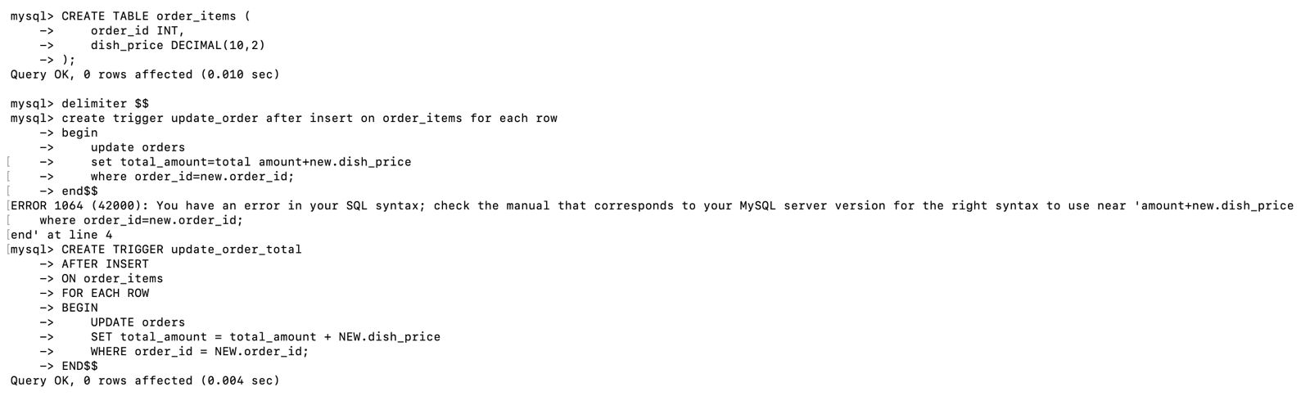

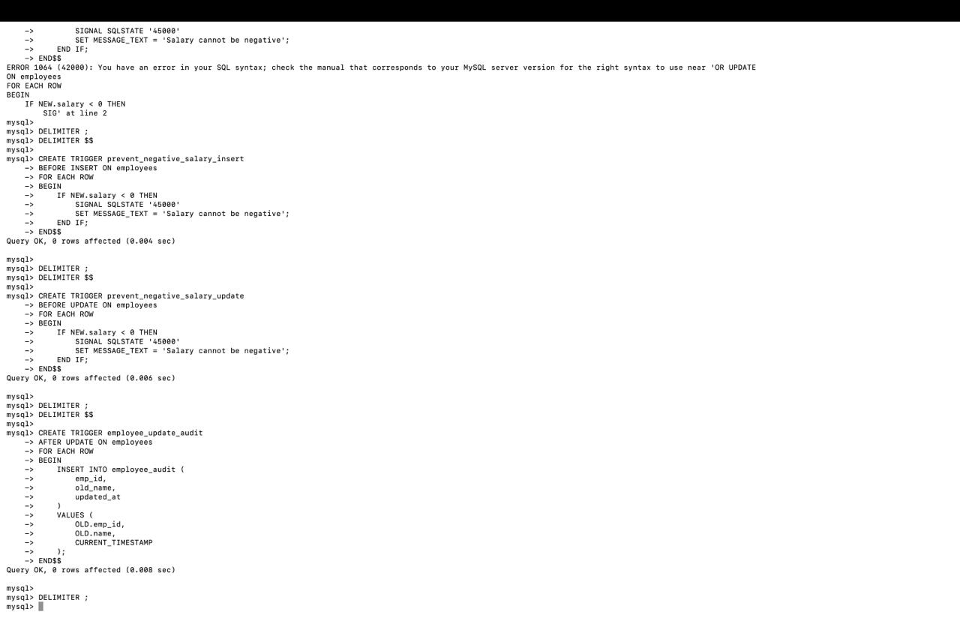

mysql> use online_banking_system;
Reading table information for completion of table and column names
You can turn off this feature to get a quicker startup with -A

Database changed
mysql> select DATEDIFF('2026-02-04','2026-02-02') as no_of_days from users;
+------------+
| no_of_days |
+------------+
| 2 |
| 2 |
| 2 |
| 2 |
+------------+
4 rows in set (0.005 sec)

mysql> select DATE_ADD('2026-02-01',INTERVAL 30 DAY) AS expiry_date from users;
+-------------+
| expiry_date |
+-------------+
| 2026-03-03 |
| 2026-03-03 |
| 2026-03-03 |
| 2026-03-03 |
+-------------+
4 rows in set (0.001 sec)

mysql> select DATE_SUB(curdate(),INTERVAL 7 DAY) AS BEFORE_7_DAYS from users;
+---------------+
| BEFORE_7_DAYS |
+---------------+
| 2026-01-28 |
| 2026-01-28 |
| 2026-01-28 |
| 2026-01-28 |
+---------------+
4 rows in set (0.001 sec)

mysql> select * from users where daoofweek(created_date) in (1,7);
ERROR 1305 (42000): FUNCTION online_banking_system.daoofweek does not exist
mysql> select * from users where dayofweek(created_date) in (1,7);
ERROR 1054 (42S22): Unknown column 'created_date' in 'where clause'
mysql> select * from users where DAYOFWEEK(created_date) in (1,7);
ERROR 1054 (42S22): Unknown column 'created_date' in 'where clause'
mysql> select * from transactions where dayofweek(created_date) in (1,7);
ERROR 1054 (42S22): Unknown column 'created_date' in 'where clause'
mysql> describe transactions;
+------------------+-----------------------------------------+------+-----+-------------------+-------------------+
| Field | Type | Null | Key | Default | Extra |
+------------------+-----------------------------------------+------+-----+-------------------+-------------------+
| transaction_id | bigint | NO | PRI | NULL | auto_increment |
| from_account | bigint | YES | MUL | NULL | |
| to_account | bigint | YES | MUL | NULL | |
| amount | decimal(15,2) | NO | | NULL | |
| transaction_type | enum('deposit','withdrawal','transfer') | NO | | NULL | |
| status | enum('success','failed') | NO | | NULL | |
| created_at | timestamp | YES | | CURRENT_TIMESTAMP | DEFAULT_GENERATED |
+------------------+-----------------------------------------+------+-----+-------------------+-------------------+
7 rows in set (0.007 sec)

mysql> SELECT *
-> FROM transactions
-> WHERE DAYOFWEEK(created_at) IN (1, 7);
Empty set (0.003 sec)

mysql> select * from transactions where DAYOFWEEK(created_at) in (3,7);
Empty set (0.001 sec)

mysql> select MONTHNAME(str_to_date('2026-02-04','%y-%m-%d'))as month_name;
+------------+
| month_name |
+------------+
| NULL |
+------------+
1 row in set, 1 warning (0.002 sec)

mysql> select MONTHNAME(str_to_date('2026-02-04','%Y-%m-%d'))as month_name;
+------------+
| month_name |
+------------+
| February |
+------------+
1 row in set (0.001 sec)

mysql> describe users;
+------------+--------------------------+------+-----+-------------------+-------------------+
| Field | Type | Null | Key | Default | Extra |
+------------+--------------------------+------+-----+-------------------+-------------------+
| USER_ID | bigint | NO | PRI | NULL | auto_increment |
| NAME | varchar(89) | NO | | NULL | |
| EMAIL | varchar(89) | YES | | NULL | |
| PASSWORD | varchar(789) | NO | | NULL | |
| ROLE | enum('CUSTOMER','ADMIN') | YES | | CUSTOMER | |
| Created_at | timestamp | YES | | CURRENT_TIMESTAMP | DEFAULT_GENERATED |
+------------+--------------------------+------+-----+-------------------+-------------------+
6 rows in set (0.002 sec)

mysql> create INDEX IDS_EMAIL on users(email);
Query OK, 0 rows affected (0.033 sec)
Records: 0 Duplicates: 0 Warnings: 0

mysql> describe users;
+------------+--------------------------+------+-----+-------------------+-------------------+
| Field | Type | Null | Key | Default | Extra |
+------------+--------------------------+------+-----+-------------------+-------------------+
| USER_ID | bigint | NO | PRI | NULL | auto_increment |
| NAME | varchar(89) | NO | | NULL | |
| EMAIL | varchar(89) | YES | MUL | NULL | |
| PASSWORD | varchar(789) | NO | | NULL | |
| ROLE | enum('CUSTOMER','ADMIN') | YES | | CUSTOMER | |
| Created_at | timestamp | YES | | CURRENT_TIMESTAMP | DEFAULT_GENERATED |
+------------+--------------------------+------+-----+-------------------+-------------------+
6 rows in set (0.002 sec)

mysql> select 8from users;
ERROR 1054 (42S22): Unknown column '8from' in 'field list'
mysql> select *fro useers;
ERROR 1064 (42000): You have an error in your SQL syntax; check the manual that corresponds to your MySQL server version for the right syntax to use near 'fro useers' at line 1
mysql> select *from users;
+---------+----------+-----------------------------+----------+----------+---------------------+
| USER_ID | NAME | EMAIL | PASSWORD | ROLE | Created_at |
+---------+----------+-----------------------------+----------+----------+---------------------+
| 1 | MANOJ | kotkurumanojkumar@gmail.com | 1235678 | CUSTOMER | 2026-01-02 10:55:01 |
| 2 | AKASH | akash@gmail.com | akash123 | ADMIN | 2026-01-02 10:55:01 |
| 3 | JITENDRA | jithendra@gmail.com | jithu123 | CUSTOMER | 2026-01-02 10:55:01 |
| 4 | JASWANTH | jaswanth@gmail.com | jashu123 | ADMIN | 2026-01-02 10:55:01 |
+---------+----------+-----------------------------+----------+----------+---------------------+
4 rows in set (0.001 sec)

mysql> select *from users where email='kotkurumanojkumar@gmail.com';
+---------+-------+-----------------------------+----------+----------+---------------------+
| USER_ID | NAME | EMAIL | PASSWORD | ROLE | Created_at |
+---------+-------+-----------------------------+----------+----------+---------------------+
| 1 | MANOJ | kotkurumanojkumar@gmail.com | 1235678 | CUSTOMER | 2026-01-02 10:55:01 |
+---------+-------+-----------------------------+----------+----------+---------------------+
1 row in set (0.001 sec)

mysql> mysql> create unique index idx_username on users(name);
ERROR 1064 (42000): You have an error in your SQL syntax; check the manual that corresponds to your MySQL server version for the right syntax to use near 'name)' at line 1
mysql> create unique INDEX idx_username on users('name');
ERROR 1064 (42000): You have an error in your SQL syntax; check the manual that corresponds to your MySQL server version for the right syntax to use near ''name')' at line 1
mysql> create unique INDEX idx_username on users('NAME');
ERROR 1064 (42000): You have an error in your SQL syntax; check the manual that corresponds to your MySQL server version for the right syntax to use near ''NAME')' at line 1
mysql> create UNIQUE INDEX idx_username on users('NAME');
ERROR 1064 (42000): You have an error in your SQL syntax; check the manual that corresponds to your MySQL server version for the right syntax to use near ''NAME')' at line 1
mysql> alter table users change NAME username varchar(100);
Query OK, 0 rows affected (0.042 sec)
Records: 0 Duplicates: 0 Warnings: 0

mysql> create UNIQUE INDEX idx_username on users(username);
Query OK, 0 rows affected (0.024 sec)
Records: 0 Duplicates: 0 Warnings: 0

mysql> create unique INDEX IDX_EMAIL on users(email);
Query OK, 0 rows affected (0.034 sec)
Records: 0 Duplicates: 0 Warnings: 0

mysql> select*from users;
+---------+----------+-----------------------------+----------+----------+---------------------+
| USER_ID | username | EMAIL | PASSWORD | ROLE | Created_at |
+---------+----------+-----------------------------+----------+----------+---------------------+
| 1 | MANOJ | kotkurumanojkumar@gmail.com | 1235678 | CUSTOMER | 2026-01-02 10:55:01 |
| 2 | AKASH | akash@gmail.com | akash123 | ADMIN | 2026-01-02 10:55:01 |
| 3 | JITENDRA | jithendra@gmail.com | jithu123 | CUSTOMER | 2026-01-02 10:55:01 |
| 4 | JASWANTH | jaswanth@gmail.com | jashu123 | ADMIN | 2026-01-02 10:55:01 |
+---------+----------+-----------------------------+----------+----------+---------------------+
4 rows in set (0.001 sec)

mysql> select index fromusers;
ERROR 1064 (42000): You have an error in your SQL syntax; check the manual that corresponds to your MySQL server version for the right syntax to use near 'index fromusers' at line 1
mysql> select index from users;
ERROR 1064 (42000): You have an error in your SQL syntax; check the manual that corresponds to your MySQL server version for the right syntax to use near 'index from users' at line 1
mysql> select INDEX from users;
ERROR 1064 (42000): You have an error in your SQL syntax; check the manual that corresponds to your MySQL server version for the right syntax to use near 'INDEX from users' at line 1
mysql> SHOW INDEX from users;
+-------+------------+--------------+--------------+-------------+-----------+-------------+----------+--------+------+------------+---------+---------------+---------+------------+
| Table | Non_unique | Key_name | Seq_in_index | Column_name | Collation | Cardinality | Sub_part | Packed | Null | Index_type | Comment | Index_comment | Visible | Expression |
+-------+------------+--------------+--------------+-------------+-----------+-------------+----------+--------+------+------------+---------+---------------+---------+------------+
| users | 0 | PRIMARY | 1 | USER_ID | A | 4 | NULL | NULL | | BTREE | | | YES | NULL |
| users | 0 | idx_username | 1 | username | A | 4 | NULL | NULL | YES | BTREE | | | YES | NULL |
| users | 0 | IDX_EMAIL | 1 | EMAIL | A | 4 | NULL | NULL | YES | BTREE | | | YES | NULL |
| users | 1 | IDS_EMAIL | 1 | EMAIL | A | 4 | NULL | NULL | YES | BTREE | | | YES | NULL |
+-------+------------+--------------+--------------+-------------+-----------+-------------+----------+--------+------+------------+---------+---------------+---------+------------+
4 rows in set (0.007 sec)

mysql> mysql> drop idx_email(akash@email.com) on users;
ERROR 1064 (42000): You have an error in your SQL syntax; check the manual that corresponds to your MySQL server version for the right syntax to use near '(akash@email.com) on users' at line 1
mysql> drop index iidx_email on users;
ERROR 1091 (42000): Can't DROP 'iidx_email'; check that column/key exists
mysql> drop INDEX idx_email on users;
Query OK, 0 rows affected (0.018 sec)
Records: 0 Duplicates: 0 Warnings: 0

mysql> drop INDEX idx_email(akash@gmail.com) on users;
ERROR 1064 (42000): You have an error in your SQL syntax; check the manual that corresponds to your MySQL server version for the right syntax to use near '(akash@gmail.com) on users' at line 1
mysql> show index on users;
ERROR 1064 (42000): You have an error in your SQL syntax; check the manual that corresponds to your MySQL server version for the right syntax to use near 'on users' at line 1
mysql> show index from users;
+-------+------------+--------------+--------------+-------------+-----------+-------------+----------+--------+------+------------+---------+---------------+---------+------------+
| Table | Non_unique | Key_name | Seq_in_index | Column_name | Collation | Cardinality | Sub_part | Packed | Null | Index_type | Comment | Index_comment | Visible | Expression |
+-------+------------+--------------+--------------+-------------+-----------+-------------+----------+--------+------+------------+---------+---------------+---------+------------+
| users | 0 | PRIMARY | 1 | USER_ID | A | 4 | NULL | NULL | | BTREE | | | YES | NULL |
| users | 0 | idx_username | 1 | username | A | 4 | NULL | NULL | YES | BTREE | | | YES | NULL |
| users | 1 | IDS_EMAIL | 1 | EMAIL | A | 4 | NULL | NULL | YES | BTREE | | | YES | NULL |
+-------+------------+--------------+--------------+-------------+-----------+-------------+----------+--------+------+------------+---------+---------------+---------+------------+
3 rows in set (0.003 sec)

mysql> create INDEX idx_aadhar on users(aadhar);
ERROR 1072 (42000): Key column 'aadhar' doesn't exist in table
mysql> describe accounts;
+----------------+---------------------------+------+-----+-------------------+-------------------+
| Field | Type | Null | Key | Default | Extra |
+----------------+---------------------------+------+-----+-------------------+-------------------+
| account_id | bigint | NO | PRI | NULL | auto_increment |
| user_id | bigint | NO | MUL | NULL | |
| account_number | varchar(20) | NO | UNI | NULL | |
| account_type | enum('savings','current') | NO | | NULL | |
| balance | decimal(15,2) | NO | | 0.00 | |
| status | enum('active','blocked') | YES | | active | |
| created_at | timestamp | YES | | CURRENT_TIMESTAMP | DEFAULT_GENERATED |
+----------------+---------------------------+------+-----+-------------------+-------------------+
7 rows in set (0.004 sec)

mysql> select*from accounts;
+------------+---------+----------------+--------------+-----------+--------+---------------------+
| account_id | user_id | account_number | account_type | balance | status | created_at |
+------------+---------+----------------+--------------+-----------+--------+---------------------+
| 5 | 1 | SBI0000001 | savings | 75000.00 | active | 2026-01-02 11:00:23 |
| 6 | 2 | SBI0000002 | savings | 120000.50 | active | 2026-01-02 11:00:23 |
| 7 | 3 | SBI0000003 | savings | 50000.75 | active | 2026-01-02 11:00:23 |
| 8 | 4 | SBI0000004 | savings | 95000.00 | active | 2026-01-02 11:00:23 |
+------------+---------+----------------+--------------+-----------+--------+---------------------+
4 rows in set (0.003 sec)

mysql> create INDEX idx_account_number on users(account_number);
ERROR 1072 (42000): Key column 'account_number' doesn't exist in table
mysql> create INDEX idx_account_number on accounts(account_number);
Query OK, 0 rows affected (0.027 sec)
Records: 0 Duplicates: 0 Warnings: 0

mysql> select*from accounts where account_number='SBI0000001';
+------------+---------+----------------+--------------+----------+--------+---------------------+
| account_id | user_id | account_number | account_type | balance | status | created_at |
+------------+---------+----------------+--------------+----------+--------+---------------------+
| 5 | 1 | SBI0000001 | savings | 75000.00 | active | 2026-01-02 11:00:23 |
+------------+---------+----------------+--------------+----------+--------+---------------------+
1 row in set (0.001 sec)

mysql> create INDEX idx_s_cr on users(status,created_at);
ERROR 1072 (42000): Key column 'status' doesn't exist in table
mysql> create INDEX idx_s_cr on accounts(status,created_at);
Query OK, 0 rows affected (0.029 sec)
Records: 0 Duplicates: 0 Warnings: 0

mysql> select*from accounts where status='active' order by created_at;
+------------+---------+----------------+--------------+-----------+--------+---------------------+
| account_id | user_id | account_number | account_type | balance | status | created_at |
+------------+---------+----------------+--------------+-----------+--------+---------------------+
| 5 | 1 | SBI0000001 | savings | 75000.00 | active | 2026-01-02 11:00:23 |
| 6 | 2 | SBI0000002 | savings | 120000.50 | active | 2026-01-02 11:00:23 |
| 7 | 3 | SBI0000003 | savings | 50000.75 | active | 2026-01-02 11:00:23 |
| 8 | 4 | SBI0000004 | savings | 95000.00 | active | 2026-01-02 11:00:23 |
+------------+---------+----------------+--------------+-----------+--------+---------------------+
4 rows in set (0.001 sec)

mysql> select email,concat(substring(email,'@',1),'123') as password from users;
+-----------------------------+----------+
| email | password |
+-----------------------------+----------+
| akash@gmail.com | 123 |
| jaswanth@gmail.com | 123 |
| jithendra@gmail.com | 123 |
| kotkurumanojkumar@gmail.com | 123 |
+-----------------------------+----------+
4 rows in set, 5 warnings (0.003 sec)

mysql> describe veltech;
+------------+-------------+------+-----+---------+-------+
| Field | Type | Null | Key | Default | Extra |
+------------+-------------+------+-----+---------+-------+
| user_id | int | YES | | NULL | |
| name | varchar(45) | YES | | NULL | |
| account_no | varchar(78) | YES | | NULL | |
| acc_type | varchar(34) | YES | | NULL | |
| balance | int | YES | | NULL | |
+------------+-------------+------+-----+---------+-------+
5 rows in set (0.003 sec)

mysql> describe customers;;
+---------------+-------------+------+-----+---------+-------+
| Field | Type | Null | Key | Default | Extra |
+---------------+-------------+------+-----+---------+-------+
| customer_id | int | YES | | NULL | |
| name | varchar(89) | YES | | NULL | |
| email | varchar(67) | YES | | NULL | |
| phone_no | varchar(89) | YES | | NULL | |
| date_of_birth | date | YES | | NULL | |
| status | varchar(45) | YES | | NULL | |
+---------------+-------------+------+-----+---------+-------+
6 rows in set (0.003 sec)

ERROR:
No query specified

mysql> select *from customers;
+-------------+-------+------------------------+------------+---------------+--------+
| customer_id | name | email | phone_no | date_of_birth | status |
+-------------+-------+------------------------+------------+---------------+--------+
| 25025 | MANOJ | kotkurumanojkumar | 8317607955 | 2025-01-27 | active |
| 26567 | MANOJ | manoj@gmail.com | 9010030003 | 2025-01-27 | active |
| 25024 | akash | bandaruakash@gmail.com | 9014744204 | 2025-01-27 | active |
+-------------+-------+------------------------+------------+---------------+--------+
3 rows in set (0.003 sec)

mysql> select contact, reg_replace(contact,'[^0-9]','') as valid contact from customers;
ERROR 1064 (42000): You have an error in your SQL syntax; check the manual that corresponds to your MySQL server version for the right syntax to use near 'contact from customers' at line 1
mysql> select name,concat(upper(substring(name,1,1)),lower(substring(name,2))) as normal_name from customers;
+-------+-------------+
| name | normal_name |
+-------+-------------+
| MANOJ | Manoj |
| MANOJ | Manoj |
| akash | Akash |
+-------+-------------+
3 rows in set (0.001 sec)

mysql> select contact, REGEXP_REPLACE(contact,'[^0-9]','') as valid contact from customers;
ERROR 1064 (42000): You have an error in your SQL syntax; check the manual that corresponds to your MySQL server version for the right syntax to use near 'contact from customers' at line 1
mysql> select contact, REGEXP_REPLACE(contact,'[^0-9]','') as valid_contact from customers;
ERROR 1054 (42S22): Unknown column 'contact' in 'field list'
mysql> select phone_no, REGEXP_REPLACE(phone_no,'[^0-9]','') as valid_contact from customers;
+------------+---------------+
| phone_no | valid_contact |
+------------+---------------+
| 8317607955 | 8317607955 |
| 9010030003 | 9010030003 |
| 9014744204 | 9014744204 |
+------------+---------------+
3 rows in set (0.016 sec)

mysql> select name, coalesce(customer_id,phone_no)as preffered_contact from customers;
+-------+-------------------+
| name | preffered_contact |
+-------+-------------------+
| MANOJ | 25025 |
| MANOJ | 26567 |
| akash | 25024 |
+-------+-------------------+
3 rows in set (0.001 sec)

mysql> select customer_id, avg(phone_no) as avg_phone_no from customers group by customer_id;
+-------------+--------------+
| customer_id | avg_phone_no |
+-------------+--------------+
| 25025 | 8317607955 |
| 26567 | 9010030003 |
| 25024 | 9014744204 |
+-------------+--------------+
3 rows in set (0.003 sec)

mysql> select customer_id, avg(phone_no) as avg_phone_no from customers;
ERROR 1140 (42000): In aggregated query without GROUP BY, expression #1 of SELECT list contains nonaggregated column 'online_banking_system.customers.customer_id'; this is incompatible with sql_mode=only_full_group_by
mysql> SELECT AVG(phone_no) AS avg_phone_no
-> FROM customers;
+--------------+
| avg_phone_no |
+--------------+
| 8780794054 |
+--------------+
1 row in set (0.001 sec)

mysql>

